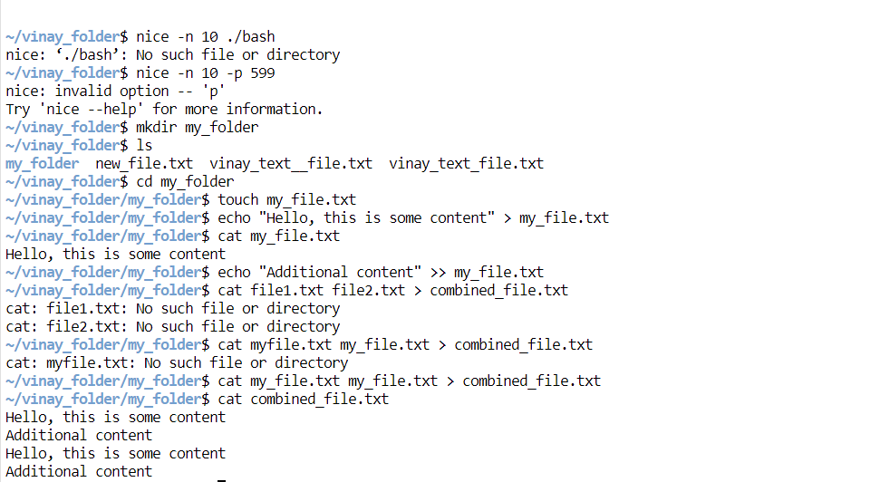

1. Mkdir: mkdir command is used to create a new directory in the present working directory.  
   eg: mkdir my_folder  
   The command mkdir my_folder which has been used above create a new folder.
2. Ls: ls command is used to list all the files and directories in the present working directory.  
   eg: ls
3. Cd: cd command is used to change the directory from present working directory to the user defined directory.  
   eg: cd my_folder  
   The above command will change my directory from root directory to the my_folder directory
4. Touch: touch command is used to create multiple files at the same time  
   eg: touch my_file.txt file1.txt file2.txt  
   the above command creates 3 files with no content in them.
5. Cat: cat command is used to view the content in the file or append the content of multiple files to a file.  
   eg: i). cat file1.txt ii). Cat file1.txt file2.txt > file3.txt  
   The i) command is used to display the content in the file file1.txt, ii) command is used to append the content of file1.txt and file2.txt to file3.txt.
6. Echo: echo command is used to print content on the screen, it can also be used to insert or append values to the file.  
   eg: i). echo “Hello” >file.txt ii). echo “Hello” >> file.txt  
   i) command is used overwrite content to the file. ii) command is used to append the content with the existing content of the file.

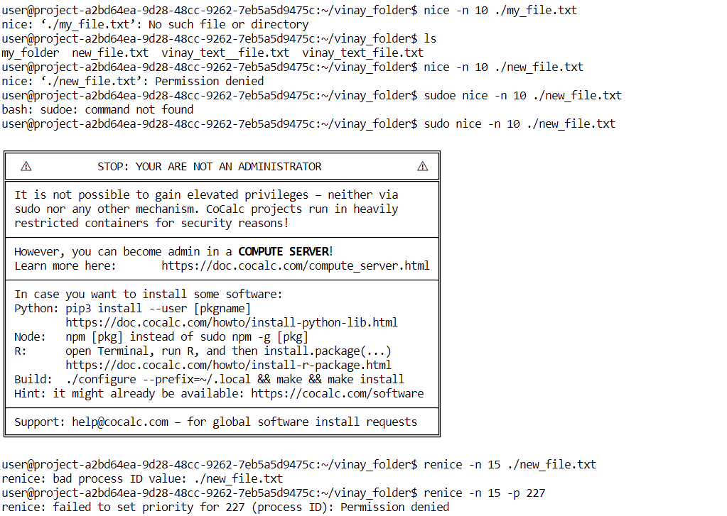

1. Nice: nice command is used to set priority to a process  
   eg: nice -9 process_name  
   the command nice with -9 is the priority level (range from -20 to 20) followed by process name.  
   The above executed command is not working because there are no much user started process to set priority
2. Renice: renice command is used to reset the priority of a process whose priority was already set  
   eg: renice -n 9 -p 225  
   here 9 is the new priority level and 225 is the process id and -n and -p are the options of renice command

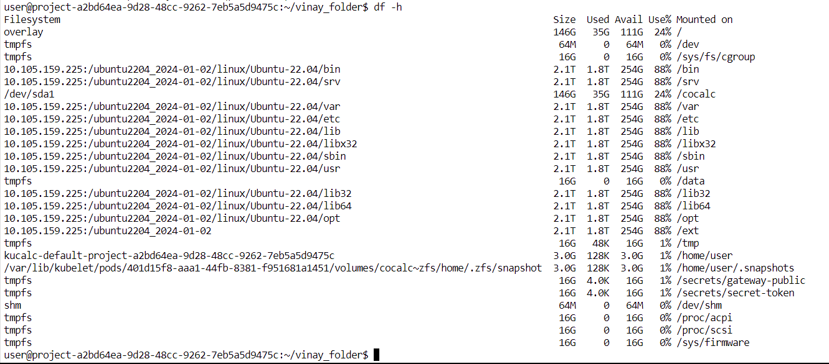

1. Df: df command is used to check the disk memory free size

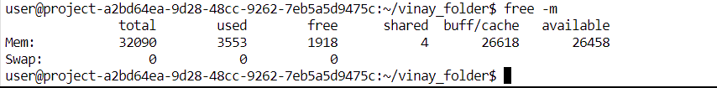

1. Free: free command is used to check how much memory overall is free

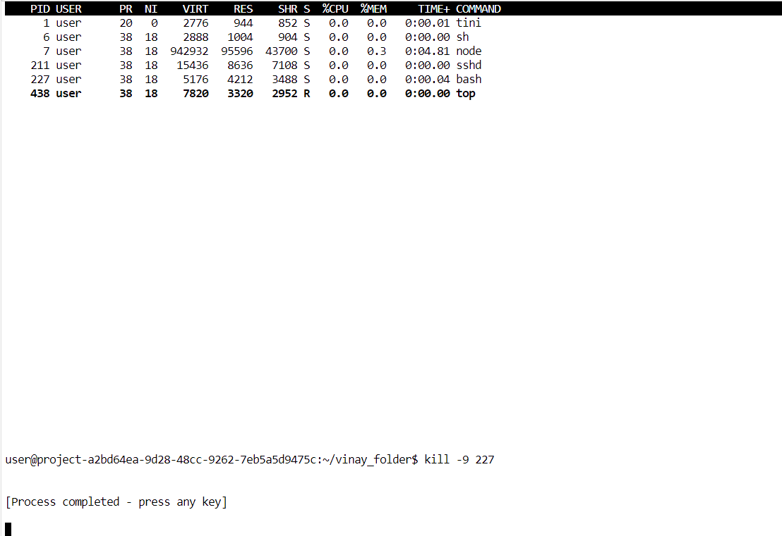

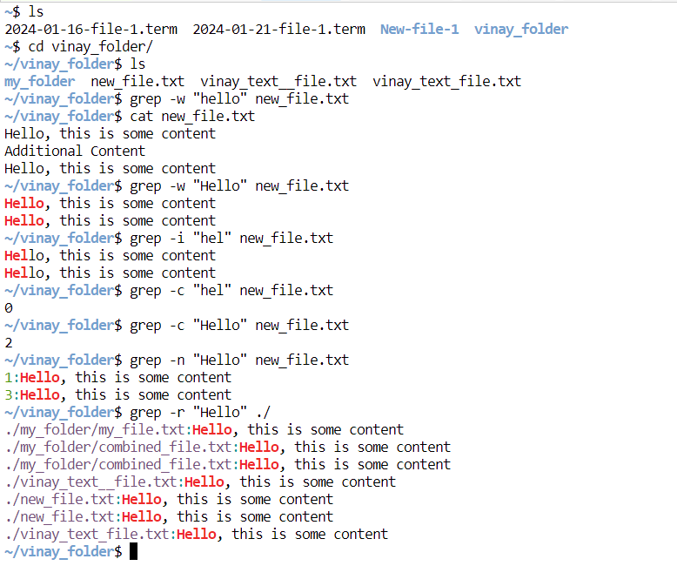

Grep command: grep command is used for pattern matching in linux.

-w: This option is used to match the whole text

-i: search for case-insensitive

-c: used to count the number of occurances

-n: number of line of the occurance

-r: recursively check all the files for the pattern in the directory